11-Nov-2022

Bootstrap Color🡪

Primary

Secondary

Info

Success

Warning

Danger

Dark

Light

White

Background color🡪

bg-primary

bg-danger

bg-success

bg-white

Change text color🡪

Text-primary

Text-warning

Text align🡪

Text-center

text-start

text-end

Text transform🡪

Text-uppercase

Text-lowercase

Text-capitalize

Font size🡪

Fs-(1-6)

Fs-1

Fs-2

…

…

Font-weight🡪

fw-bold

fw-bolder

fw-semobold

fw-normal

fw-light

fw-lighter

font-style:normal | Italic

fst-normal

fst-italic

text-decoration🡪

text- decoration -underline

text- decoration -overline

text- decoration -line-through

heading🡪

h1

h2

h3

h4

h5

h6

Bootstrap Alert Box-🡪

Alert alert-danger

Alert alert-primary

…………..

Width 🡪

w-100 100%

w-50 50%

w-25 25%

Bootstrap buttons--------------🡪

btn btn-danger

btn btn-success

……………………

Buttons with outline-🡪

Btn btn-outline-danger

Btn btn-outline-success

Btn btn-outline-warning

……………….

Padding🡪

p- Value(0-5)

p-1🡪(top left right bootm)

pt=> padding top

pb=> padding bottom

BSV4 pl=> padding -left BSV5ps🡺 ps

BSVE pr=> padding right BSV5 pe=> padding end

ps=>padding start

px=> padding-start & padding end

py=> padding top & padding bottom.

Margin🡪

M value(0-5)

Mt-margine-top

Mb-margin-bottom

Ms-margin-start(BSV4 ml=> margin left)

Me-Margin end(BSV4 mr=> margin right)

M=>top left right and bottom

Mx=> margin start & margin end

My=> margin top & margin bottom

mx-auto (margin:0px auto

Image responsive🡪

BSV4=> img-responsive

BSV5=> img-fluid, img-thumnail

Float-left => float-start

Float-right => float-end

Border radius🡪

Rounded

Rounded-top

Rounded-start

Rounded-bottom

Rounded-end

Rounded-pill

Border🡪

Border

**14-Nov-2022**

**Grid System:🡪**

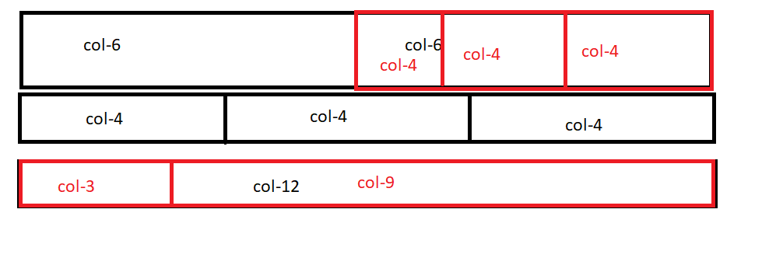

**Break Point:-**

Sm for small deivice (mobile) 🡨 576px

Md for medium screen (tab) 🡨 768px

Lg :- for large screen () 🡨 992px

Xl:- for extra large screen (Tv) 🡨 1200px

Xxl:- for extra extra large screen (extra large Tv) 🡨 1400px

**Syntax:-**

Col-sm-*

Col-ms-*

Col-lg-*

Col-xl-*

Col-xxl-*

**Glyphicn:-** glyphicon glyphicon-home🡪 fontawesome.com

**17-Nov-2022**